Sacred Heart Parish, 210 E. Northampton St., Bath, PA
Name:____________________________ MATEY’S PIZZA AND MR. PASTIES Date: __________________
ORDER FORM Cash: ________________
Phone #________________________ ONLY ONE ORDER FORM PER WEEK Check: _______________

$7.50 $7.50 $7.50 $7.50 $9.50 $6.00 $6.00
Customer  Name | 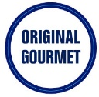  Mozzarella & Provolone | 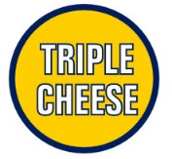  Mozz, Prov, Cheddar | 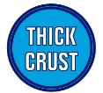  Mozz, Prov, Cheddar | 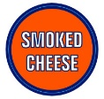  Smoked Mozz & Provolone | Mozz, Prov,  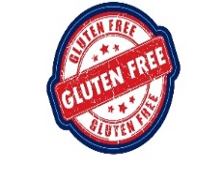  Cheddar | Pasties  Spinach  8 oz.  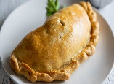 | Pasties  7 Veggies  8 oz. | MONEY  TOTAL
TOTALS
PLEASE CHECK - Week AND Pick-Up Time Listed Below (Make check payable to Sacred Heart Parish)

Week 3: _____Order due by 3/15/2023 - Pick Up Date: 3/24/2023
Time of Pick-Up (check one): _____ 4:00-5:00 PM OR ________ 6:45-7:45 PM

Orders due every Wednesday by 3:00 pm for the following Friday. Order form and money can be returned to the parish offices, collection basket or mailed to Sacred Heart Church, 210 E. Northampton St., Bath, PA 18014.
Pick up from 4:00 pm to 5:00 pm or 6:45 pm to 7:45 pm in the Scout Room by the Church Kitchen. Please enter the Scout Room by using the side door from the church parking lot by the Rosary Garden. Any questions, please call 610-837-6391.
All orders must be pre-ordered, pre-paid and picked up weekly.

